Day53&54 - Task28 - Docker(Part-3)

1. Create an image from running container.
- Check the existing container
- You should see my-nginx
- To use the existing container, start it:
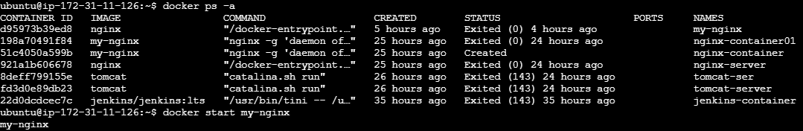
- Create an image from the running container
- Use docker commit:
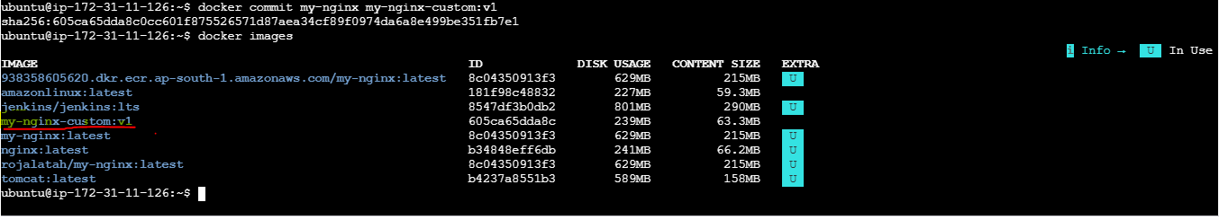

2. Copy image from local machine to docker server and load the image.
- Save the Docker image on your local machine
- Save my-nginx-custom:v1 image as a .tar file and check the file
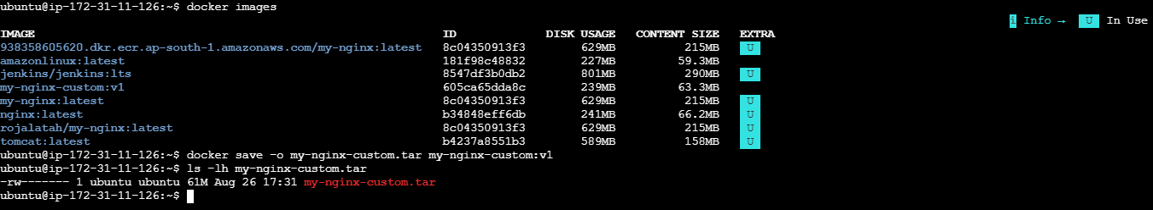
- Copy the image to the Docker server
You should now be back at your Windows PowerShell: PS C:\Users\Dell>
- You need the PEM key that allows you to SSH into Server 1 (172.31.11.126).
- If that key path is : C:\Users\Dell\Downloads\Europe.s.pemand Server 1 has a reachable public IP, run from Windows powershell:
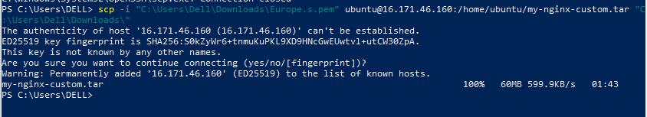
- SSH into Ubuntu server and load the docker image:
- Now connect back to ubuntu server and check whether the Docker image .tar file exists
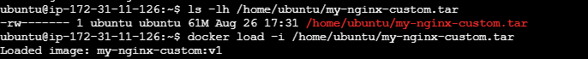
- Verify the loaded image
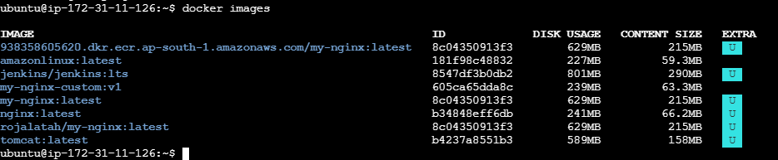

1. Create a project directory
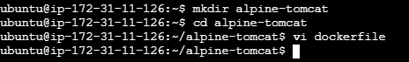
2. Create the Dockerfile
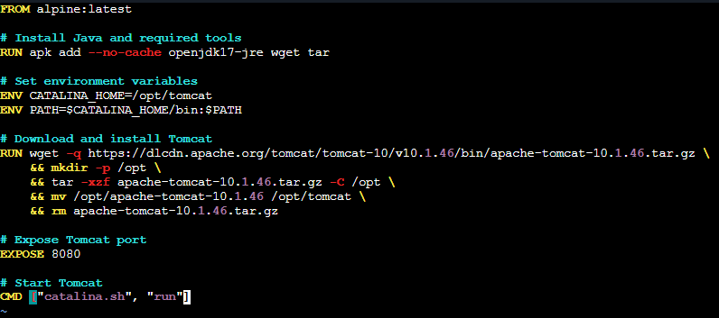
3. Build the Docker image
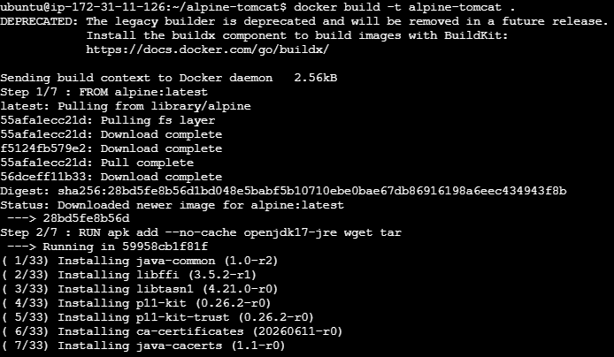

4. Verify the docker images
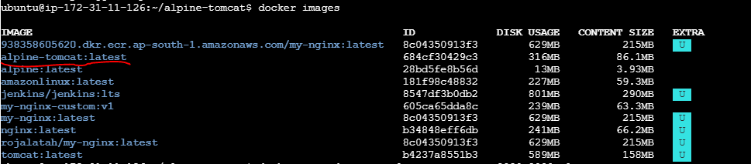
5. Run the container and verify the container
6. Access it on the browser
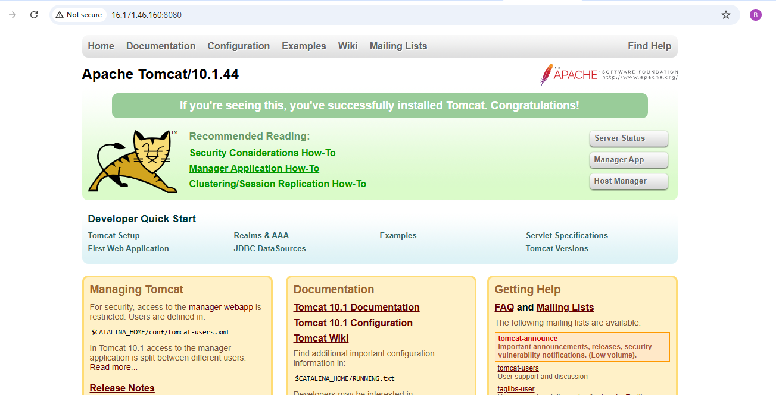

7. Verify inside the container
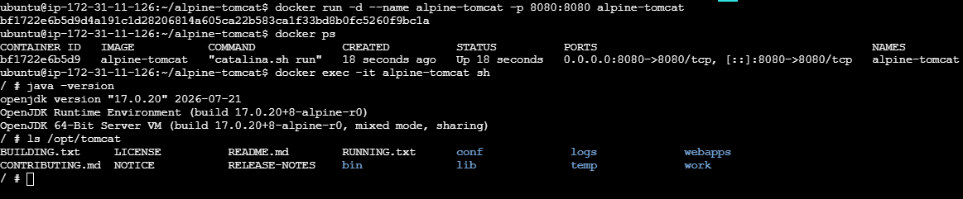

4. Create single stage and multi stage docker file using this source code:https://github.com/betawins/multi-stage-example.git

- Clone the source code
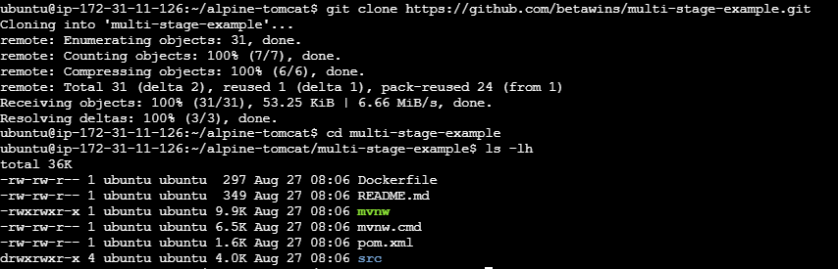

- Single-stage Dockerfile
Create Vi file
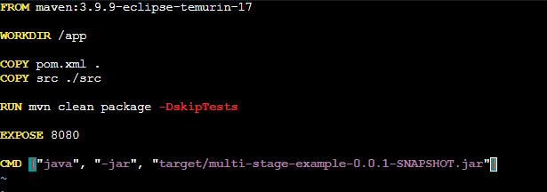
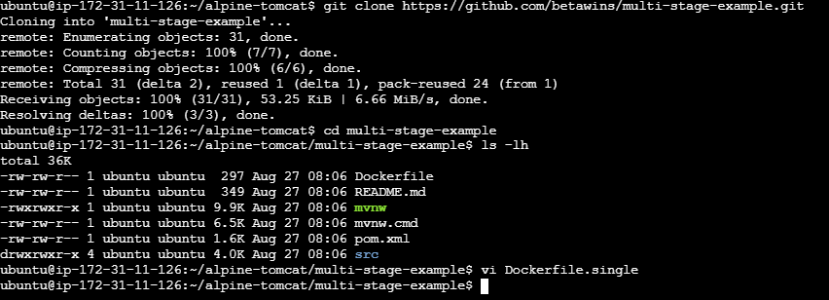
- Build the single-stage image
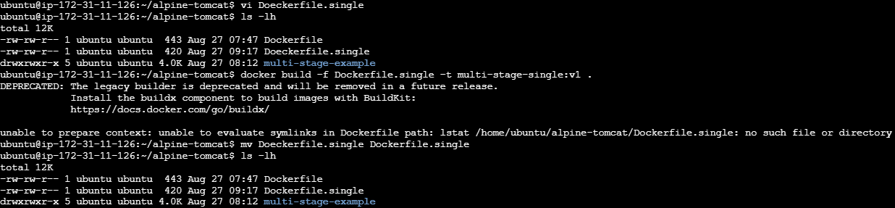
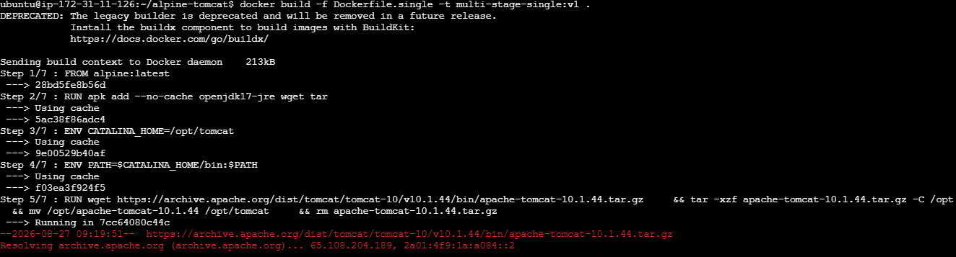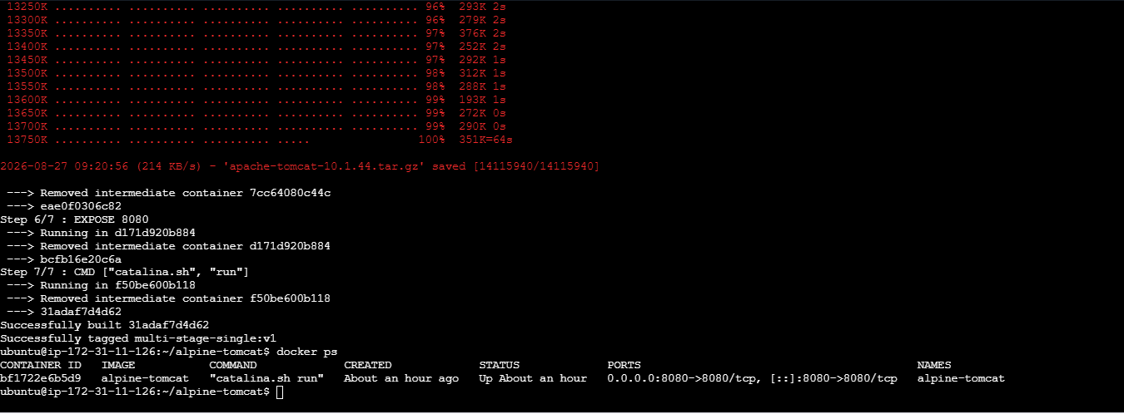

- Access it in browser:
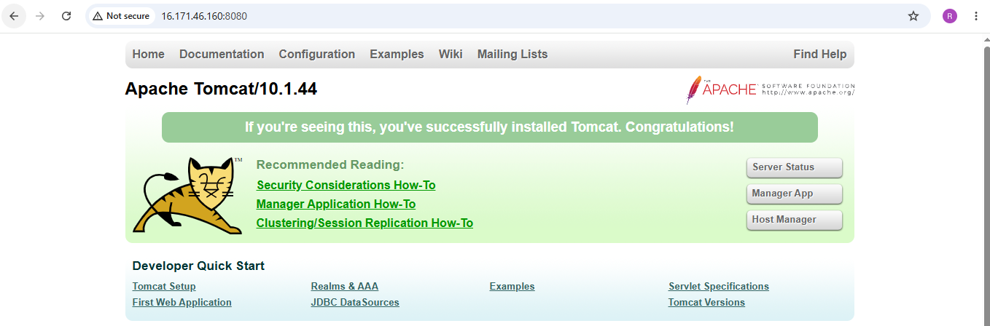

- Multi-stage Dockerfile
Now create Dockerfile.multi using vi
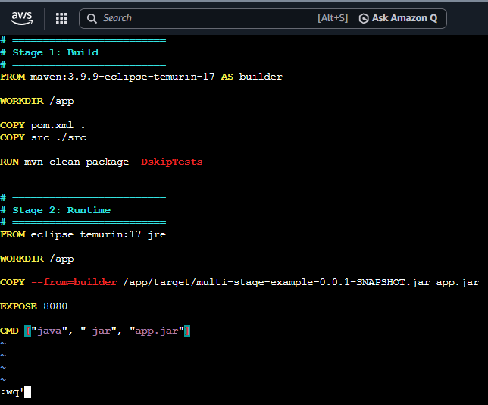
- Build Multi stage Dockerfile:
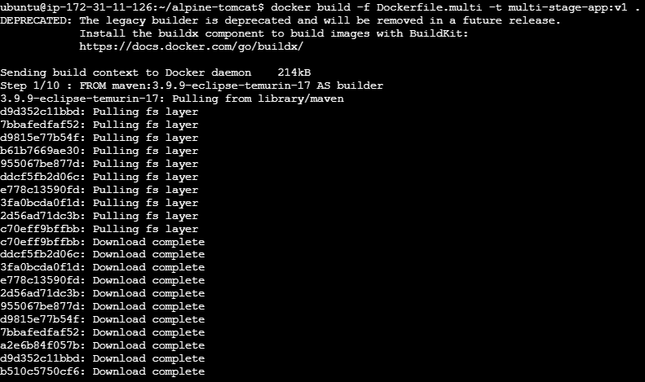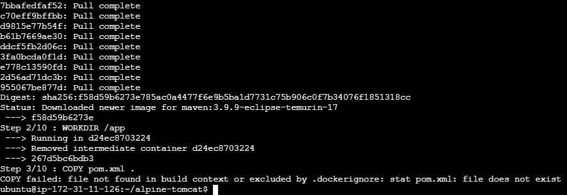
- Create and start a Docker container from the image multi-stage-app:v1, runs it in the background, gives it a name, and maps port 8084 on your server to port 8080 inside the container
- Also verify the container
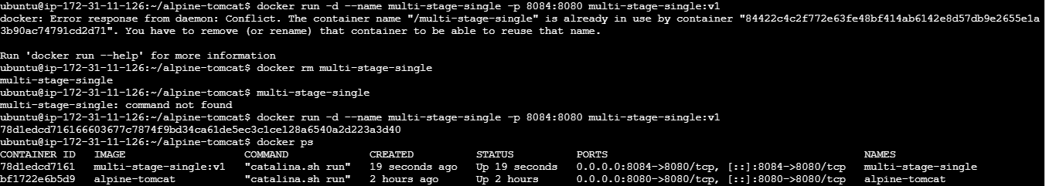
- Access it on browser
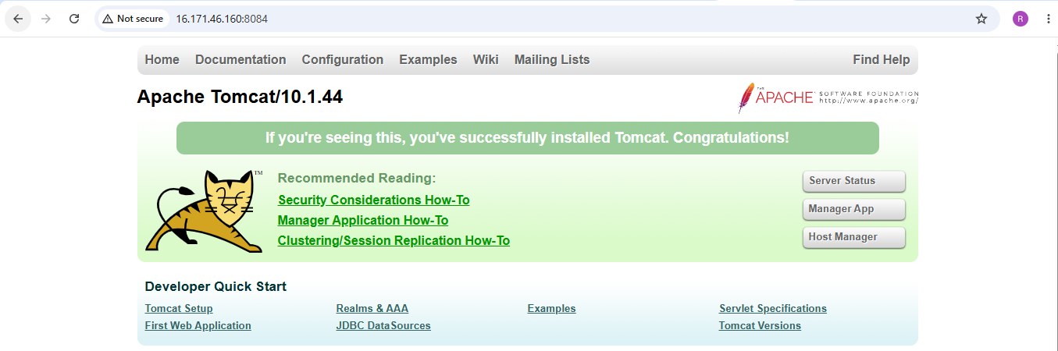
5. Install docker compose and execute sample application.

- Verify Docker and Check Docker Compose
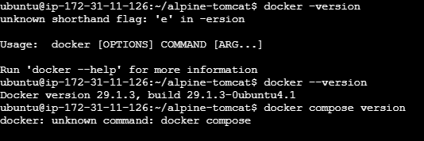
- Check Docker Compose
- Check docker compose version
- If it is not installed:
sudo apt update
sudo apt install -y
docker-compose-plugin
- Verify again: docker compose version
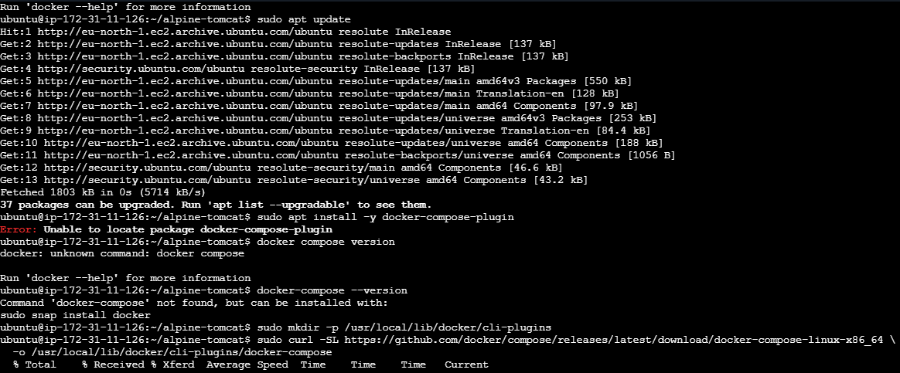
- Clone the sample application
- git clone https://github.com/betawins/multi-stage-example.git is already cloned
- Check the files: ls -la
- Create compose.yaml using Vi editor
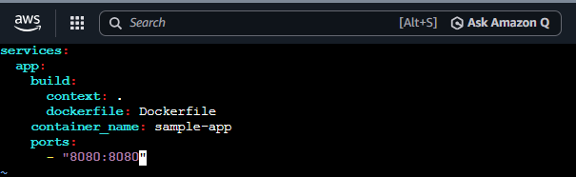

- Build and start the application
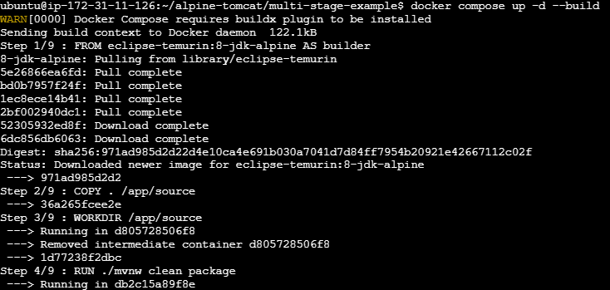
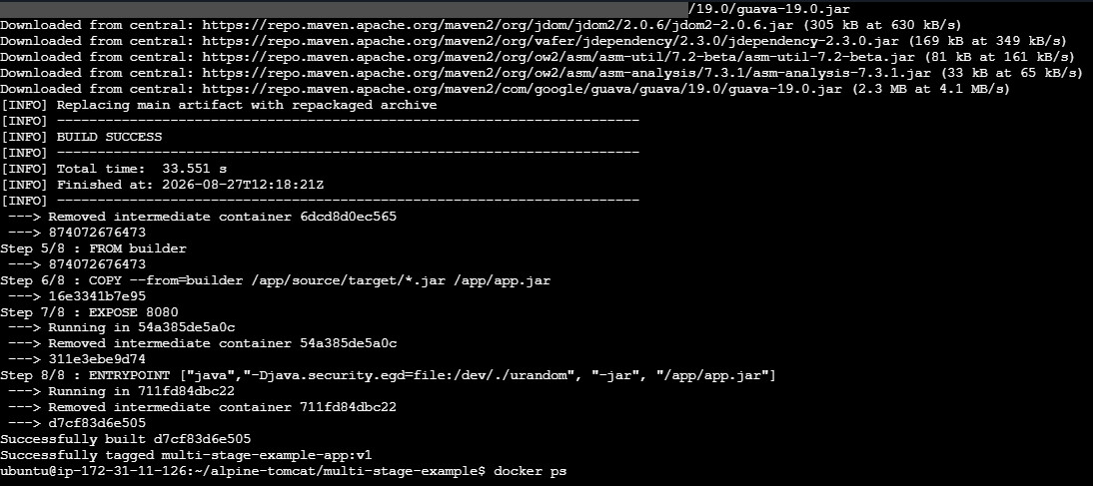

- Verified the container :
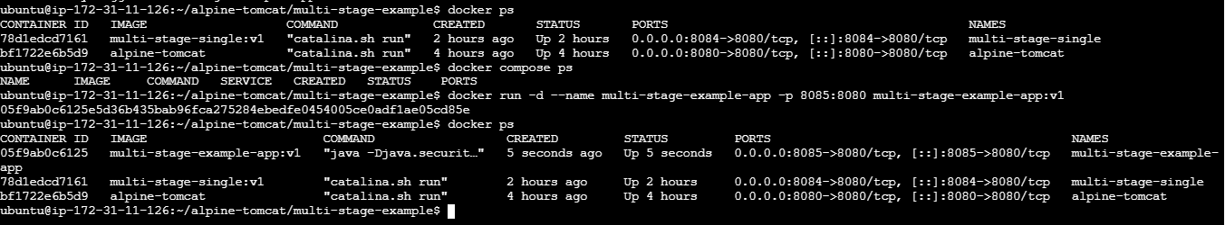
- Accessed in the browser:
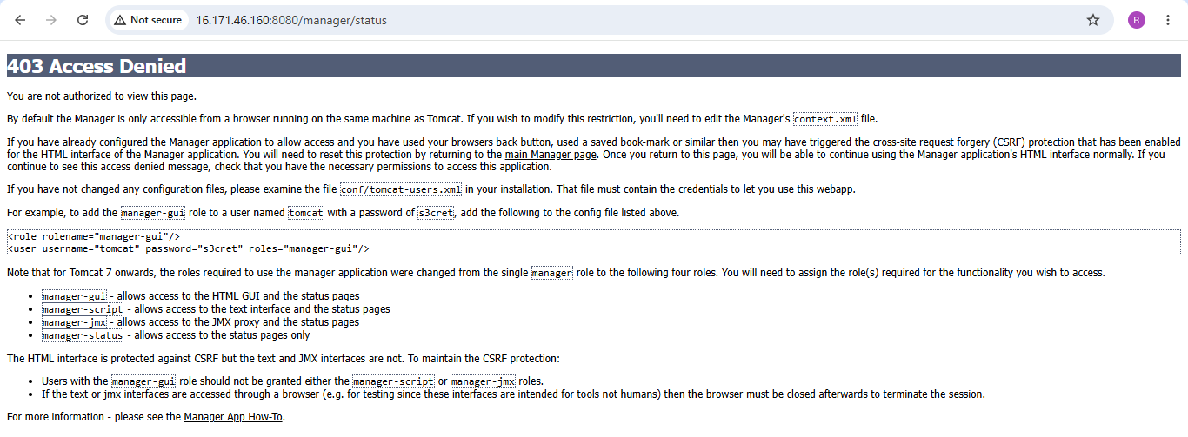

6. Implement a solution to scan images when pushed to docker registry.
- Install Trivy
- Updated the packages
- Installed wget to install the wget utility on Ubuntu.
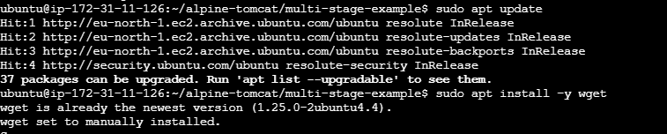

- The command used below downloads the public GPG key provided by the Trivy project.
- The key is used to verify that packages from the Trivy repository are genuinely signed by the expected publisher.

- Then added the official Trivy APT repository to Ubuntu's package sources, to install Trivy using apt.

- Updated packages and installed Trivy
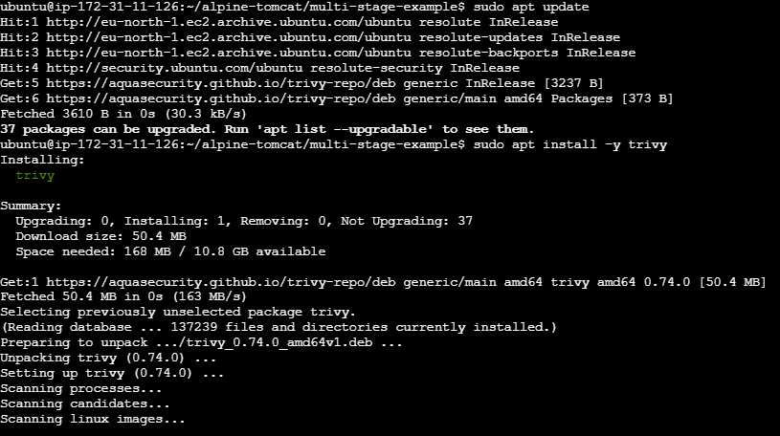
- Trivy successfully scanned and gave the following output:
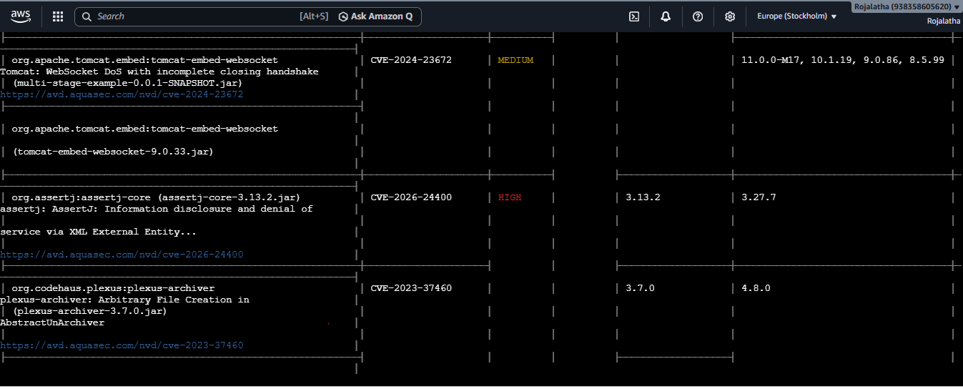
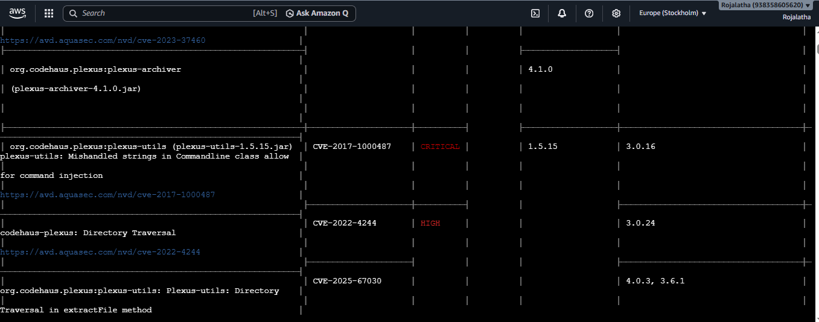
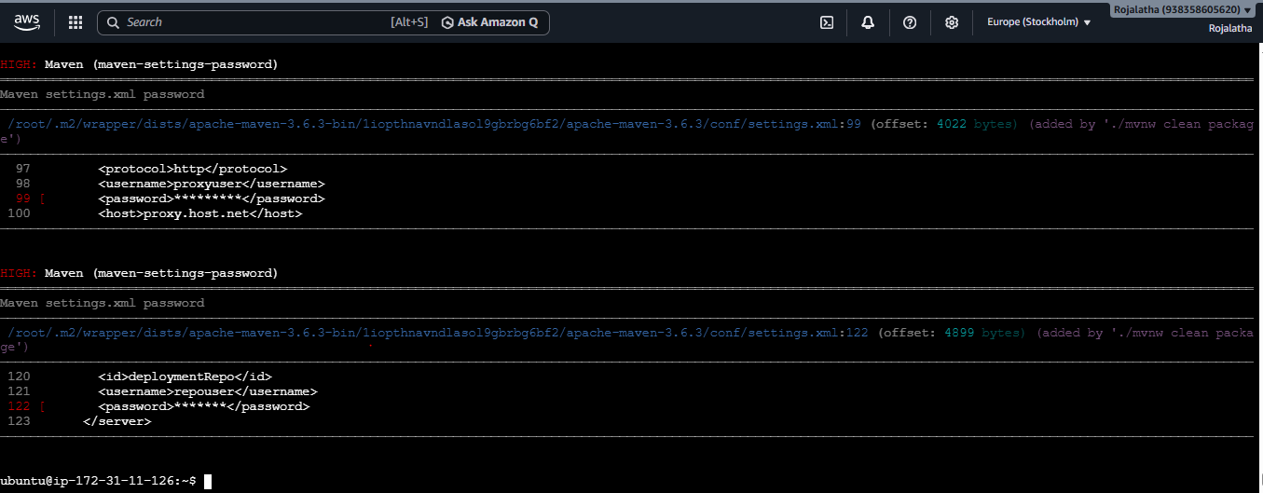

- After scan passes, pushed the image to dockerhub:
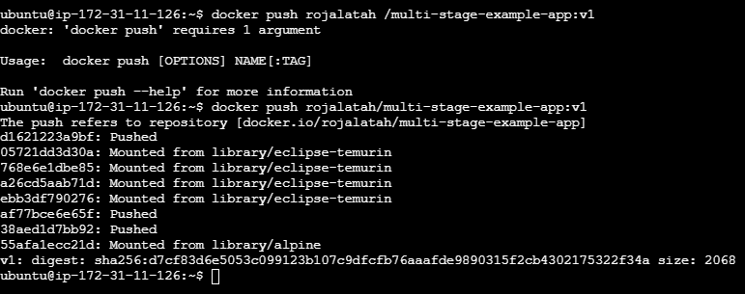

- Verified that imaged is pushed to docker-hub:
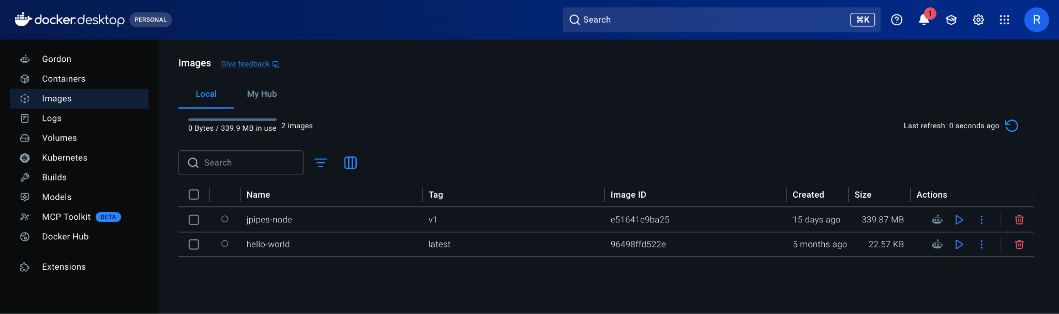
7. Implement a solution to scan images when pushed to AWS ECR.

- Enable image scanning in ECR

- Push your image
- Tag the image and push it to registry
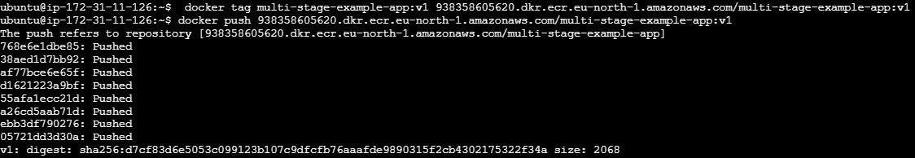
- Because scanOnPush=true, ECR automatically starts scanning the image.
- Check scan results
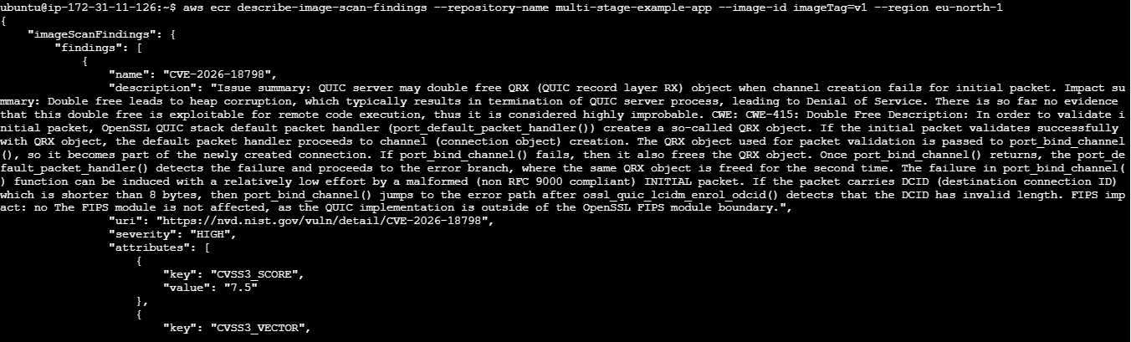
8. Create a Jenkins pipeline to create a docker image and push the image to Docker hub.

- Add Docker Hub credentials to Jenkins
- Go to: Jenkins → Manage Jenkins → Credentials → System → Global credentials → Add Credentials
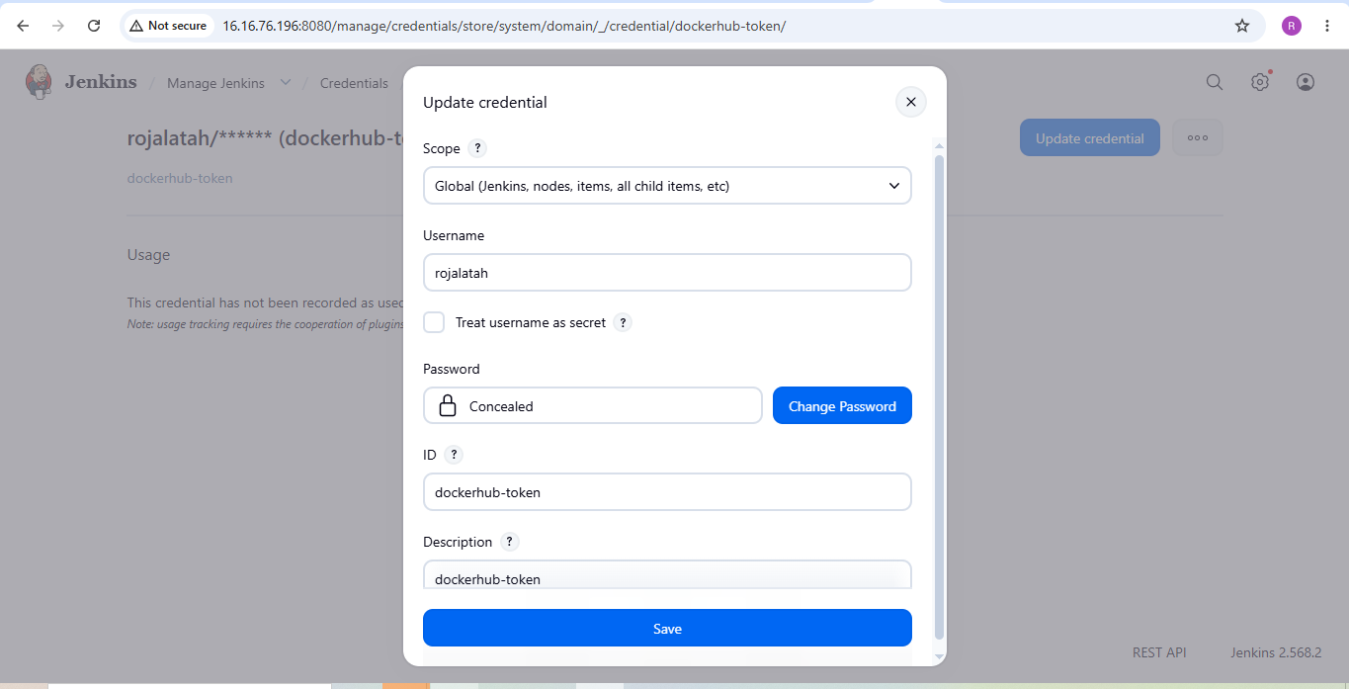

- Create the Jenkinsfile
- Go to: Jenkins → New Item
- Enter: Name: pipeline
- Select: Pipeline
- Click: OK
- Scroll down to: Pipeline
- Select: Definition: Pipeline script
- Then use the Jenkinsfile:
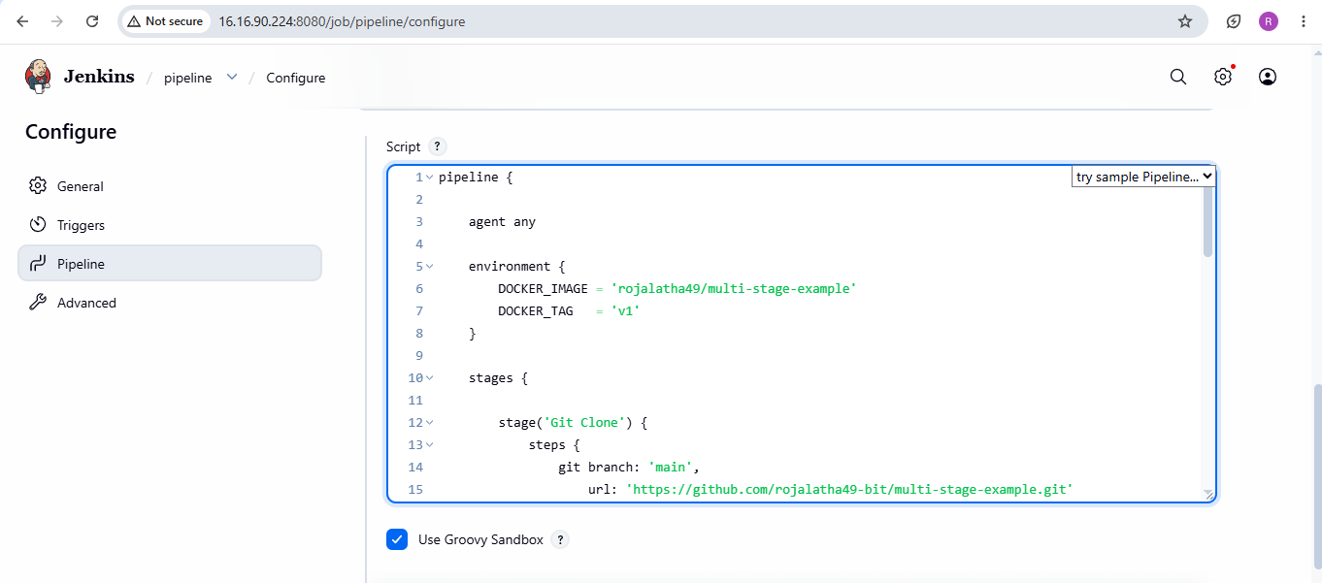
- Check git status and the commit and push the commits:
- 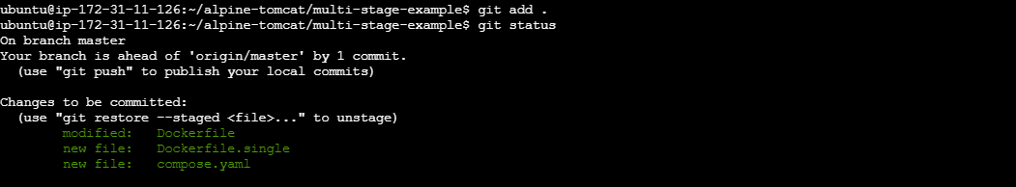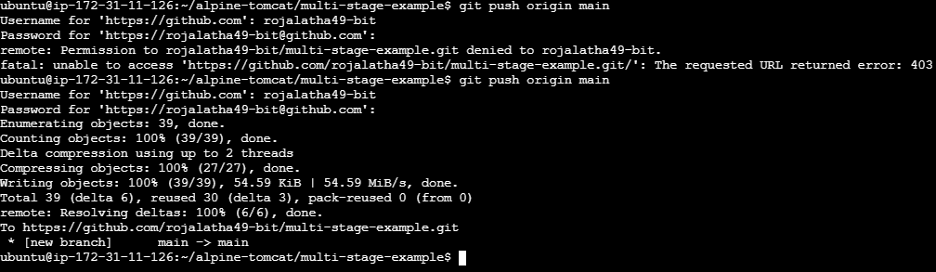
- Save and Build
- Click: Save and click on build now
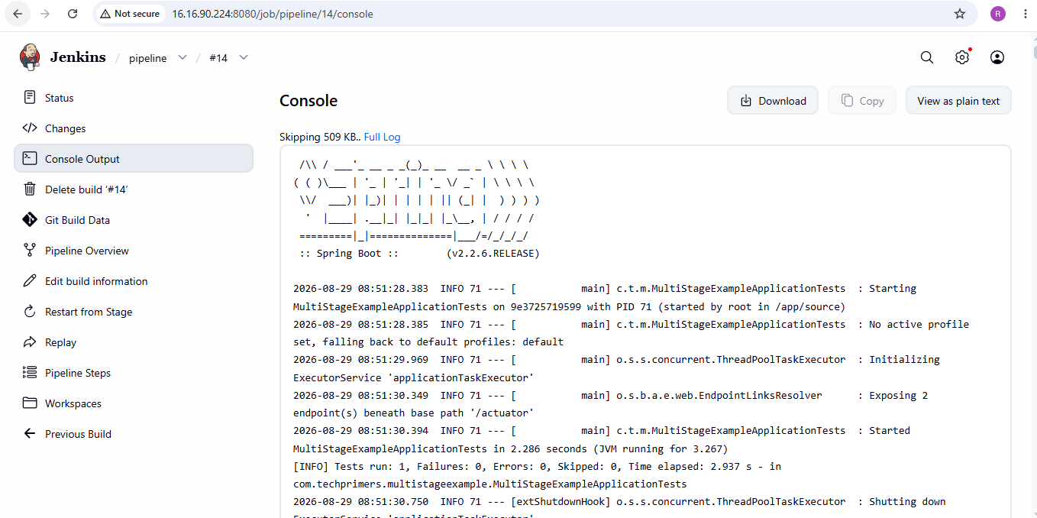
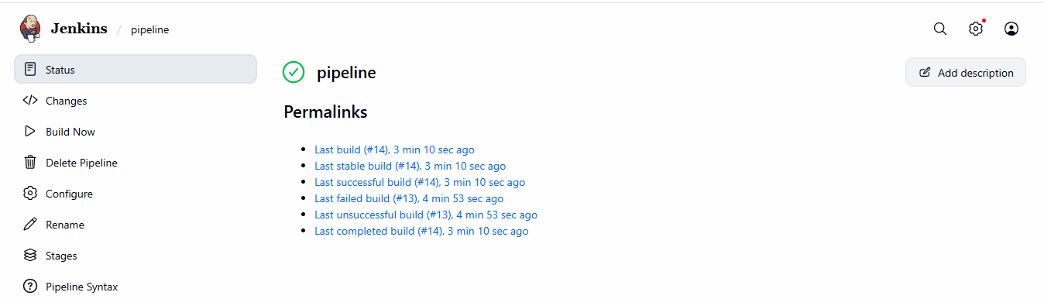

- Verified in Docker hub –repositor


